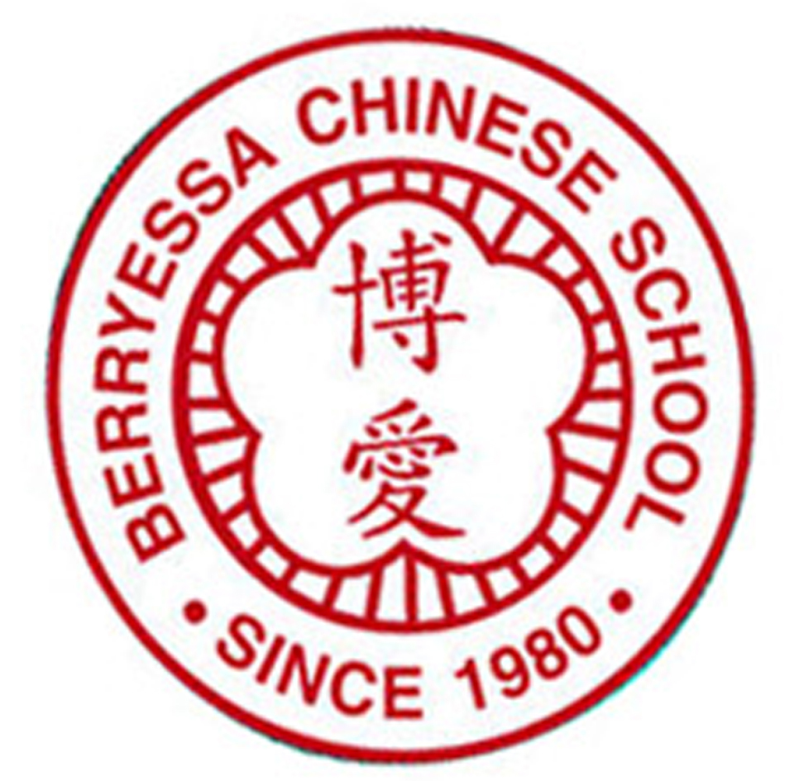 | 博愛中文學校 Berryessa Chinese School  Order Due Date: 11/23/2019  BCS 40th Anniversary T-Shirt/Yearbook “Advance Order” Form  NOTE: YearBook $25ea T-shirt $10ea Bundle (Yearbook & T-shirt): $30/set

Student Name | Youth Sizes |  |  |  |  |  |  |  | Adult Sizes |  |  |  |  |  |  |  | Year  Book | Total Cost
Student Name | Maroon |  |  |  |  |  |  |  | Maroon |  |  |  |  |  |  |  | Year  Book | Total Cost
Student Name | S | M | L | XL |  |  |  |  | S | M | L | XL |  |  |  |  | Year  Book | Total Cost
Class Total Amount
Please turn in 1 check per class payable to BCS with this order form to your Associate Dean by 11/23/2019. Thank you! Sizing chart is on reverse page.
Class___________ Class Rep_______________________Email_______________________________________Phone_________________

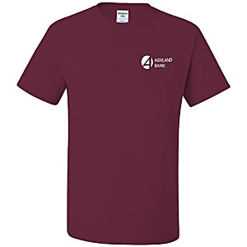
Sample Tshirts will be available for viewing in the BCS main office on Morrill campus starting 10/12.

Sample Tshirts will be available for viewing in the BCS booth during Fall Carnival in Sierramont on 10/26.

COME CHECK IT OUT!!!
The sizing information for the youth shirt is shown below:
 | XS | S | M | L | XL
Body Width (Chest Measurements (across chest) | 13 1/2 | 15 1/2 | 17 | 18 | 20
The sizing information for the adult shirt is shown below:
 | S | M | L | XL | 2XL
Body Width (Chest Measurements (across chest) | 18 | 20 | 22 | 24 | 26

