BCS 40th Anniversary Yearbook Editing Instructions
Class Submission Due: 2/15/2020 email to: yearbook@bcs-usa.org

Format:
- Each class has two pages
- Standardized format: letter size (8.5” x 11”), to be printed side by side on the yearbook
- Margin is set to be normal (1” – top, bottom, left & right)
- Use Microsoft Word and PDF only; Other formats will be rejected (No Excel, PowerPoint…)
- Word document can be saved in PDF after editing; standard size only (see instruction below)
- Soft copy (Word and PDF) and print-out
Contents:
- Free to design the layout of the two pages
- Pictures can include individual student picture with name, teacher’s picture, class picture, group activities pictures, student’s work…
- Optional to include teacher’s message, student’s thoughts on coming to BCS, group projects…
- If parent does not consent to release the student’s picture, put the student’s name on the pages instead
- Change all color photos to black & white (see instruction below)
Submission:
- File name saved to Class_Yearbook (example: C3A_Yearbook)
- Due date: 2/15/2020
- Email the pages in Word and PDF document to yearbook@bcs-usa.org
- Print a copy of the class pages and submit the physical copy to your department deans (for verification purposes)
- All questions related to yearbook should be sent to yearbook@bcs-usa.org
- Submission should consider final product, no additional editing will be done by the school yearbook team
Printing:
- All class pages will be printed on black & white
- Expect to pickup the yearbook at the end of May – announcement to be followed
BCS 40 周年年刊編輯說明
截稿日期: 2/15/2020 電子郵件至： yearbook@bcs-usa.org

格式：
1. 每班有兩頁
2. 標準格式：Letter紙張大小（8.5" x 11），在年刊上兩頁將並排列印
3. 邊沿設置為正常（1" = 頂部、底部、左側和右側）
4. 請使用微軟Word 和PDF; 其他格式將被拒絕（不接受Excel，PowerPoint..）
5. 微軟Word文檔編輯後可以保存為PDF格式；僅標準尺寸（請參閱以下說明）
6.電子文檔 (微軟Word 和PDF) 和打印副本
內容：
1. 兩頁的佈局可隨意設計
2. 圖片可以包括個別學生照片與名字，教師的照片，班級照片，在課堂上的活動照片等.
3. 可以包括教師的信息，學生對BCS的想法，學生習作...
4. 如果家長不同意發佈學生的照片，請改為只將學生的姓名放在頁面上
5. 將所有彩色照片更改為黑白（請參閱下面的說明）
提交：
1. 儲存檔案名稱為 Class_Yearbook（例如：C3A_Yearbook）
2. 截稿日期：2020年2月15日
3. 將 Word和PDF 文檔通過電子郵件發送至yearbook@bcs-usa.org
4. 把文檔打印出來，並把打印本交給您的系主任 (用於驗證)
5. 有關年刊的問題, 請電郵至yearbook@bcs-usa.org
6. 提交文檔將為完成作品，學校年刊團隊不會進行額外的編輯
印刷：
1. 年刊內頁將全以黑白印刷.
2. 年刊暫定在5月底發送– 公告將隨後公佈
How to Save Microsoft Word to PDF
Step 1: File -> Save as -> Browse -> Select Desktop or other folder location
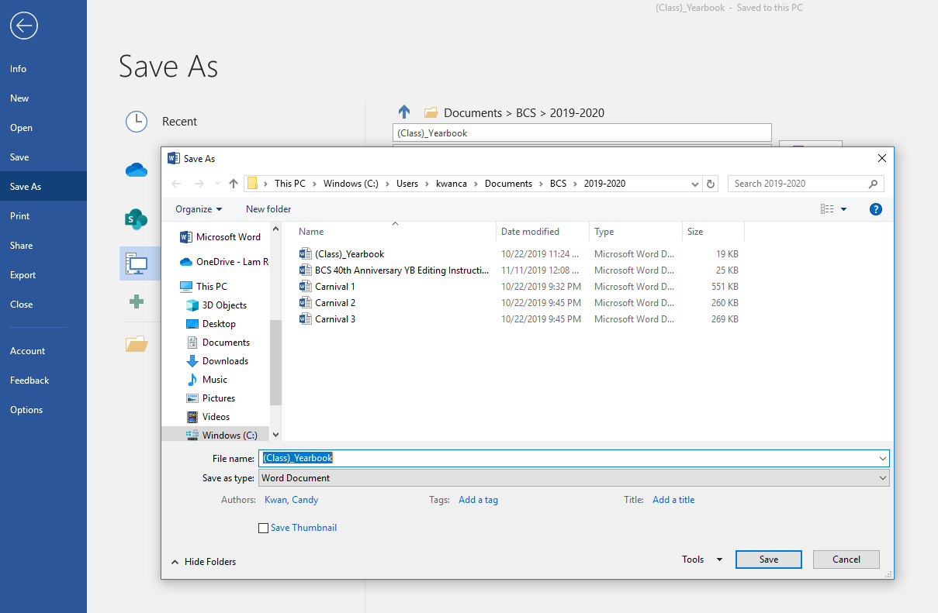

Step 2: Save as type, click drop-down menu, select PDF, make sure “Standard” size is selected
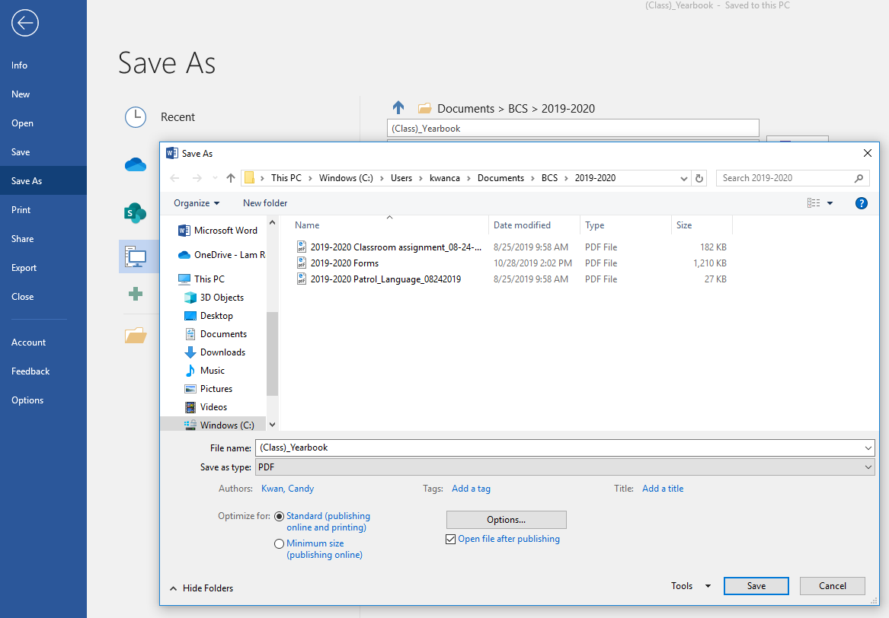

How to Change Color Photos to Black & White
Step 1: Click on the photo, the click “Format” on top -> Color (drop-down menu) -> select “Grayscale”

